**First Completely Painted Row or Column**

<https://leetcode.com/problems/first-completely-painted-row-or-column/>

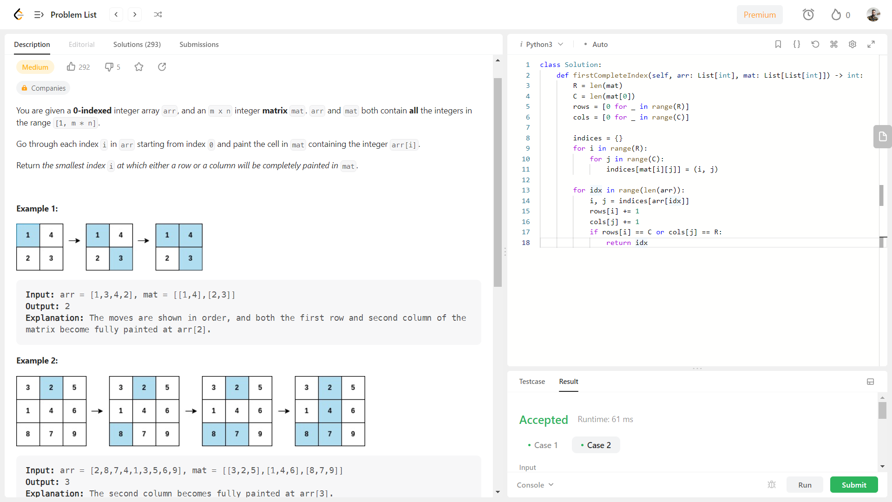

**Time complexity: O(RC)**

class Solution:

    def firstCompleteIndex(self, arr: List[int], mat: List[List[int]]) -> int:

        R = len(mat)

        C = len(mat[0])

        rows = [0 for _ in range(R)] #[0] * R

        cols = [0 for _ in range(C)]

        indices = {}

        for i in range(R):

            for j in range(C):

                indices[mat[i][j]] = (i, j)

        for idx in range(len(arr)):

            i, j = indices[arr[idx]]

            rows[i] += 1

            cols[j] += 1

            if rows[i] == C or cols[j] == R:

                return idx

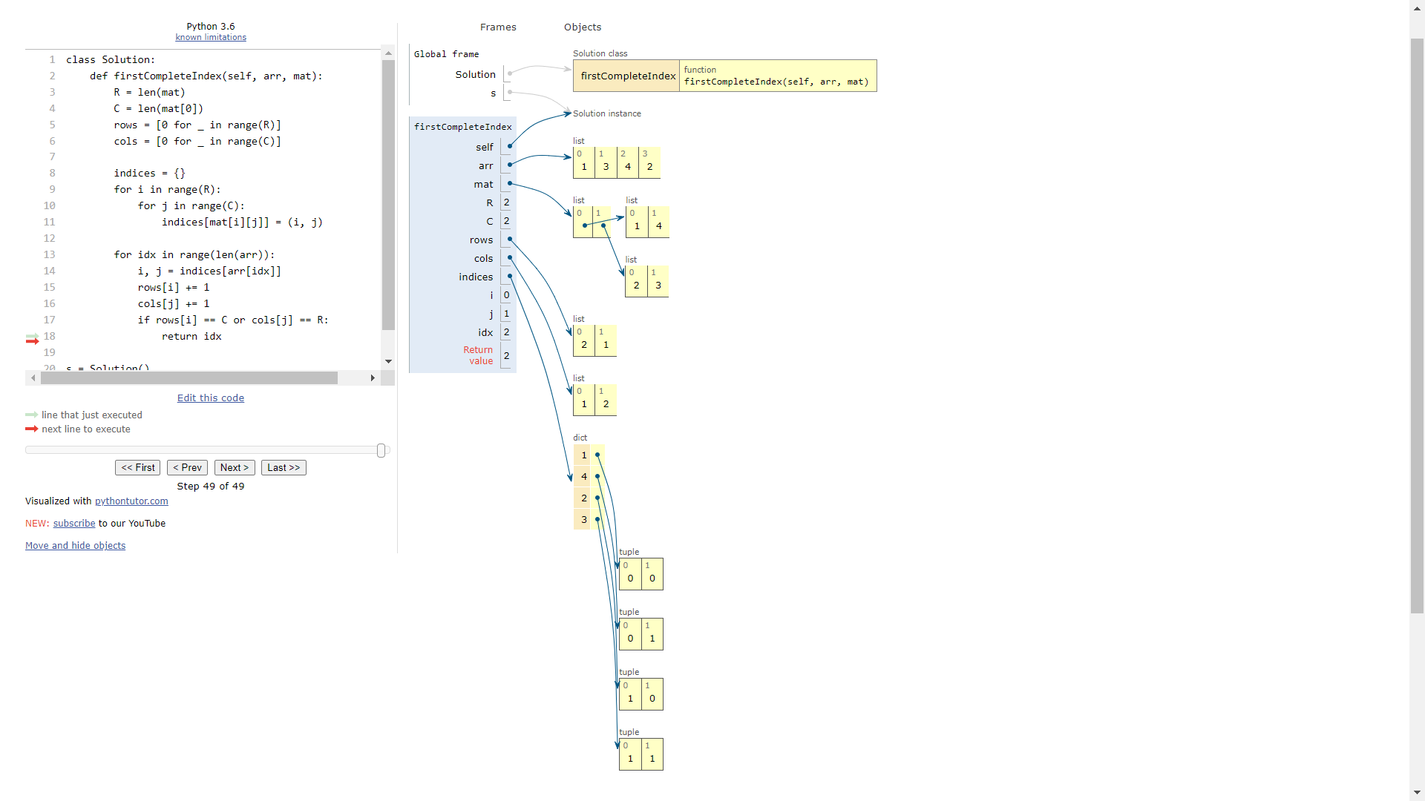

**Time complexity: O()**